



**SECTOR OF AGRICULTURE**

**MCHINJI DISTRICT COUNCIL**

**P.O. BOX 7**

**MCHINJI**



***PROGRESS REPORT HIGHLIGHTS FOR FEBRUARY, 2025***





**SUBMITTED TO:**

THE DISTRICT COMMISSIONER

MCHINJI DISTRICT COUNCIL

**THROUGH**

DIRECTOR OF AGRICULTURE SERVICES

MCHINJI DISTRICT COUNCIL

Table of Contents

1.0 Introduction 4

**Financial Status (ORT)** 4

**2.1.1.2 Weather** 6

**Rainfall** 6

Generally, the district experienced wet conditions, consistent with rainy season. 6

**Temperature** 6

**Food Availability** 7

**Food Situation** 7

**Copping Mechanism** 8

**Food Availability under the Reporting Period** 8

**2.1.2.1** **Agriculture Extension Services highlights of achievement** 8

**2.1.4 Crops Development highlights of achievements** 19

20

**2.1.4.6 Crops Plans for March, 2025** 21

# 1.0 Introduction

The sector in order to coordinate and provide guidance and direction on implementation of activities related to Agriculture it has implemented activities as highlighted below under Other Recurrent Transactions and other special programmes.

## **Financial Status (ORT)**

The Sector has an annual provision of 102,787,969 and cash flow of K6, 302,143 for February, 2025 of which nothing had been funded representing 0% funding to cash flow.

**Highlights for Human Resources for the month of January**

1. Salary processing

2. Salary progression

3. Pensions and Retirement processing

4. Salary arrears processing

5. PSR 19 and confirmations

6. Gratuity

7. Disciplinary issues

8. Staff return

9. LASCOM submissions

**The activities shown in the diagram as follows:**

|  |  |  |  |  |
| --- | --- | --- | --- | --- |
| **NO.** | **ACTIVITY** | **PROGRESS** | **TARGET** | **REMARKS** |
| 1 | Salary processing | Done and GP5 submitted to DHRMD | All changes done | Successfully done |
| 2 | Salary progression | Continuing | All files | Partially done |
| 3 | Pensions and Retirement | * Andrew Phiri (DAH), * Benard Banda (Ground Labourer), * Jonas Montfort (Messenger) * Eric Sinsamala (Messenger) | All files | Submitted to DHRMD and Treasury |
| 4 | Salary arrears | Compiled ready for processing | All files | Not yet done due lack of resources |
| 5 | PSR 19 and confirmation letters | * Advanced ready for printing * PSR 19 and confirmation letters were written for Passwell Chiumia and Christopher Phiri (water Monitoring Assistant), Mwiza Msiska (SALDHO) and Enock Thom (AVO) | 60 percent of officers | Not yet done due lack of resources |
| 6 | Gratuity | Dream Biscope (Forest Guard) | 1 file | Not yet submitted to Treasury |
| 7 | Staff return | Updated |  | Updated |
| 8 | Disciplinary issues | Disciplinary hearing for Leonard phiri and Harry Mwambulo (DAH) waiting for reports and decision from management |  | Waiting for reports and decision from management |
| 9 | LASCOM submission | Four posts were submitted for advertisement Crops Officer (Grade I), AEDO (Grade K), AVO (Grade K), Fisheries Assistant (Grade L) |  | Waiting for Advertisement |

**HUMAN RESOURCES WORK PLAN FOR THE MONTH OF MARCH 2025**

|  |  |  |  |  |
| --- | --- | --- | --- | --- |
| **NO** | **ACTIVITY** | **TARGET** | **EXPECTED OUTCOME** | **INCHARGE** |
| 1 | Updating of service record card PSR 22 continuation… | All files | Up to date files | Registry |
| 2 | Submission of Daniel Chimeta file to LASCOM | 1 File | Sorted | HRMO |
| 3 | Processing of outstanding salary arrears | All files presented | Arrears paid | HR and Accounts |
| 4 | Salary processing and submission | All employees | Everyone receives their salary | HR |

**2.0 Implementation Progress / Achievements**

**2.1 Program 002 Agriculture**

**2.1.1 Introduction**

The report covers information on the progress made on Extension service delivery, major Crop and Livestock development and Soil and Water conservation activities for the month of July, 2023. The activities were conducted in all the 6 gazetted Extension Planning Areas (EPA) namely; Mkanda, Kalulu, Mikundi, Msitu, Chioshya, Mlonyeni and 5 sub-EPAs namely, Gumba, Mkanda 2, Mikundi 2, Kapiri, Nkhwazi, and Zulu which comprised of 90 sections.

## **2.1.1.2 Weather**

**Rainfall**

Generally, the district experienced wet conditions, consistent with rainy season.

**Temperature**

It had generally the district experienced a fairly typical warm to hot temperature during the period under report.

**Effects of weather on crop development**

The prevailing weather (Dry, warm to hot weather) positively affected crops by providing good germination of crops, good establishment of transplanted tobacco seedlings and reduced leaching in crop fields.

It has negatively affected crops in the sense that it Increased incidence of pest and disease attack such as FAW, especially in areas which experienced dry spells such as Kalulu where there was an infestation of Army Worm. Delayed transplanting of rice and weed growth in fields.

**2.1.1.3** **Crop situation.**

Most of the rainfed crops were harvested while in irrigaion the crop ranged from emergency to maturity.

**Food Availability**

**Food Situation**

The food situation is generally worse compared to same time last year. Out of **149,665** Farming Households, **23,672** Farming Households did not have food of their own, representing **15.8%** compared to **9,944 out** of **149,665** Farming Households representing **6.6%** same time last year (**Table 1).**

|  |  |  |  |  |  |  |  |  |
| --- | --- | --- | --- | --- | --- | --- | --- | --- |
| **EPA** | **2024/2025** | | | | | **2023/2024** | | |
| **FHH** | **FHH without their own Food** | | | | **Total FHH** | **FHH without food** | |
| **MHH** | **FHH** | **Total** | **% Affected** | **FHH affected** | **% Affected** |
| Mkanda | 30,643 | 2,950 | 1,070 | 4,020 | 13.1% | 30643 | 1,411 | 4.6% |
| Kalulu | 16,588 | 1,244 | 2,214 | 3,458 | 20.8% | 16,588 | 670 | 4.0% |
| Mikundi | 26,497 | 1,304 | 816 | 2,120 | 8.0% | 26,497 | 1,120 | 8.0% |
| Chiosya | 14,494 | 769 | 535 | 1,304 | 9.0% | 14,494 | 1,160 | 8.0% |
| Mlonyeni | 21,264 | 1,740 | 599 | 2,339 | 11.0% | 21,264 | 2,711 | 12.7% |
| Msitu | 21,761 | 4,123 | 3,408 | 7,531 | 34.6% | 21,761 | 970 | 4.5% |
| Zulu | 18,418 | 1499 | 1,400 | 2,899 | 23.0% | 18,418 | 902 | 4.9% |
| **District** | **149,665** | **13,629** | **10,042** | **23,671** | **15.8%** | **149,665.00** | **9,944** | **6.6%** |

**Table 1:** Comparative Food Situation as on 28 January2025

**Copping Mechanism**

The food insecure farming households opted for the following coping mechanisms:

* Doing petty trade to find cash for buying food items
* Dependency on remittances from friends and relatives
* Doing piece works and using the realized cash to purchase food items

**Food Availability under the Reporting Period**

Various types of foodstuffs in homesteads and local markets were readily available. Maize grain, rice grain and beans were all available with most households. Households without own food reserves were buying from different sources such as vendors and ADMARC

Maize which is a staple food for over 90% of population of the district was available and accessible by people in the district but also cassava, bananas, beans and other food sources were available and households without food were at 4%.

**2.1.2 Agriculture Extension Services**

The Extension Department has five sections of Extension Methodology, Agribusiness Management, Food and Nutrition, Agricultural Gender Roles and Extension Support Services and Communication. In the month of February, 2025, the department through these five sections conducted a number of activities despite encountering several challenges. Below are the activities that the department conducted with targets and achievements.

### **Agriculture Extension Services highlights of achievement**

During the period under report the department implemented and achieved the following activities

**DAESS Structures which are well coordinated and operational**

The district has functional Decentralized Agriculture Extension Service System (DAESS). The district has DASC, DAECC, DASP, 18 AASPs, 172 VASPs and 1060 VACs Table 1 shows number of DAESS structures per EPA.

Table 1: Number of DAESS Structures per EPA

|  |  |  |  |  |  |  |  |  |
| --- | --- | --- | --- | --- | --- | --- | --- | --- |
| **Name of EPAs** | **Chiwosya** | **Kalulu** | **Mlonyeni** | **Mikundi** | **Mkanda** | **Msitu** | **Zulu** | **Total** |
| Number of Area Agriculture Stakeholder Panels | 1 | 4 | 1 | 3 | 7 | 1 | 1 | **18** |
| Number of Village Agriculture Stakeholder Panels | 16 | 42 | 29 | 15 | 49 | 14 | 7 | **172** |
| Number of Village Agriculture Committees | 114 | 189 | 108 | 137 | 265 | 126 | 121 | **1060** |

**PHYSICAL IMPLEMENTATION AND ACHIEVEMENTS OF EXTENSION PROGRAMS**

During the period under report the department implemented and achieved the following activities

*DAESS Structures which are well coordinated and operational*

* The period under report the district conducted 2 AASP meetings with the total participation of 41 (27m 12f)
* Conducted 12 VASP meetings with the total participation of 192 (147M 45F)

**ACHEIVEMENTS BY OTHER PROJECTS AND PROGRAMMES**

1. **TRANSFORMING AGRICULTURE THROUGH DIVERSIFICATION AND ENTREPRENEURSHIP (TRADE)**

* Conducted 4 cooking demonstration in Mkanda, Chiwosya, Mlonyeni and Zulu EPAs
* Trained 9 members of staff and 30 farmers on ACIF Grant proposal writing

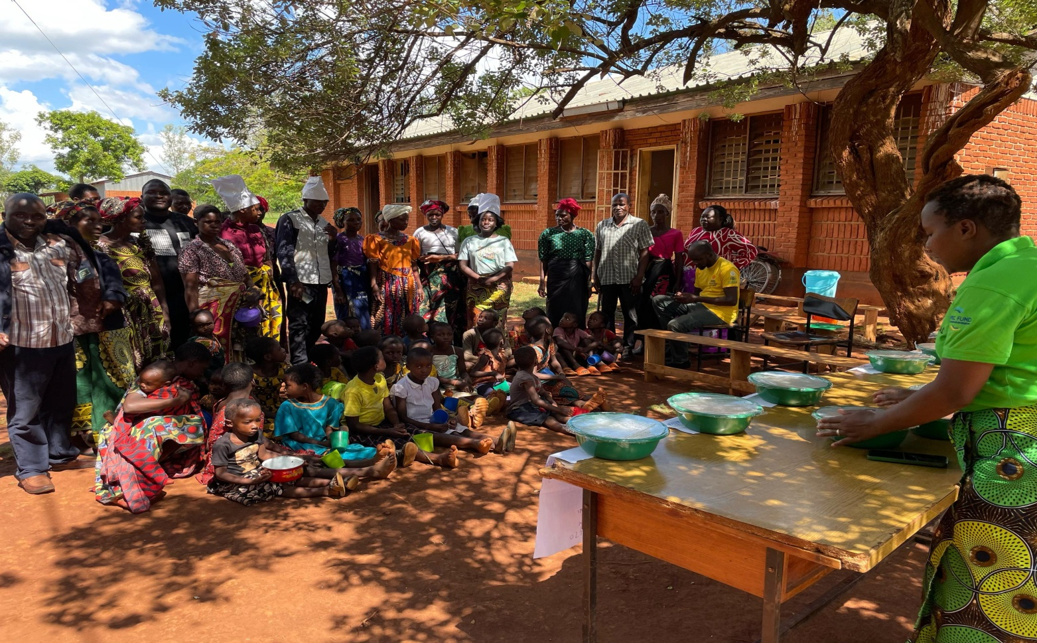

*Figure 1: Cooking demonstration in Mkanda EPA*

1. **FUM**

* Attended project training materials consolidation and harmonization workshop in Mponela
* PEAMO, ABO and AGRESSO attended TOT for Community Agribusiness Advisor Model and Safeguarding in Salima

1. **AGCOM**

* Development of business plans for cooperatives

1. **GIZ**

* Attended awareness campaign on productive use of energy

1. **GREEN LIVELIHOOD**

* Backstopping harmonized demonstration on value chains in Mkanda, Chiwosya and Mlonyeni EPAs
* Facilitated lead farmer training on monitoring harmonized demonstrations

1. **CLIMATE SMART**

* Documentation of successfully implemented activities in 24 catchment areas
* Facilitated pay parade in Kawerawera, Mthathatha, Katungulu and Guillime

**Plans For February 2025**

1. Facilitate District Agriculture Stakeholder Panel quarterly meeting
2. Facilitate field days in various EPAs
3. Backstopping EPA demonstrations
4. Backstopping AASP meetings in various Area Development Committees

#### **2.1.3 Sustainable Management of Agricultural Land**

**2.1.3.1 Soil Fertility Improvement and Agro Forestry Technologies**

**Soil Fertility Improvement Programme**

**2.1.1 MANURE MAKING**

A total of 11,922 heaps of manure have been made during the month with the involvement of 3,373 farmers of which 1,919 are males and 1,454 are females, to date 89,147 heaps have been made with the involvement of 40,393 farmers of which 21,231 are males and 19,162 are females, out of an annual target of 84,000 heaps with the involvement of 8,400 farmers of which 4,200 are males and 4,200 are females.

**2.1.2 MANURE APPLICATION**

A total of 1,079ha have been applied with various types of manure during the month with the involvement of 5,694 farmers of which 2,665 farmers are males and 3,029 are females, to date 21,755ha has been applied with various types of manure with the involvement of 73,200 farmers of which 40,824 are males and 32,376 are females, out of an annual target of 11,500 ha with the involvement of 28,750 farmers of which 14,375 are males and 14,375 are females

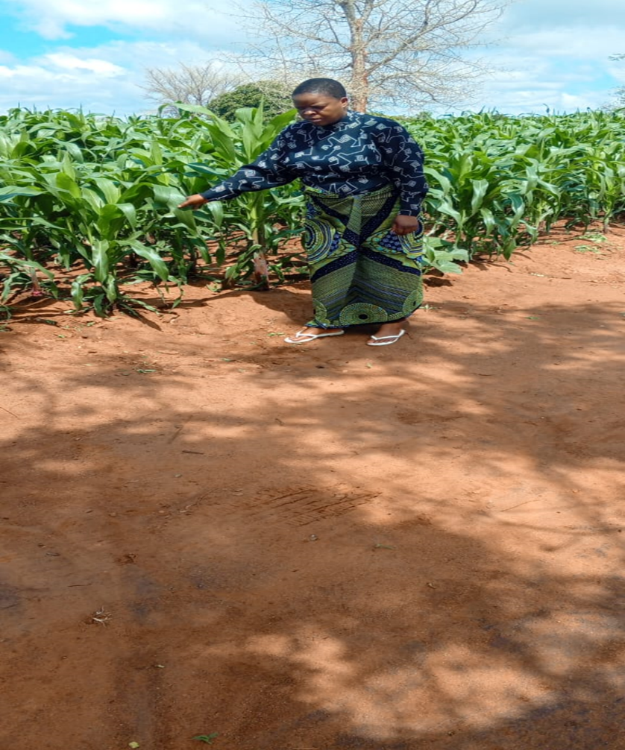

Fig shows Maize applied with Mbeya organic fertilizer in Msitu EPA

**2.1.3 CROP RESIDUE INCORPARATION**

A total of 2,258ha have been incorporated with crop residues during the month with the involvement of 5,120 farmers of which 2,191 are males and 2,929 are females, to date 32,577ha has been incorporated which involved 90,639 farmers of which 50,530 are males and 40,109 are females, out of an annual target of 20,000 ha with the involvement of 25,000 male farmers and 25,000 female farmers.

**2.1.4 AGRO FORESTRY**

21 agroforestry nurseries have been established during the month with the involvement of 1,670 farmers of which 760 are males and 910 are females, to date 403 agroforestry nurseries have been established with the involvement of 15,521 farmers of which 7,853 are males and 7,668 are females out of an annual target of 40 nurseries with the involvement of 1,200male farmers and 1,200 female farmers.

54,623 agroforestry seedlings have been raised during the month with involvement of 517 farmers of which 236 are males and 281 are females. To date 538,060 seedlings have been raised with 8,441 farmers involved of which 4,321 are males and 4,120 are females out of annual target of 160,000 seedlings with involvement of 1,200 male farmers and 1,200 female farmers.

33,088 seedlings have been planted under homestead during the month and 109ha of land being covered with the involvement of 1,520 farmers of which 772 are male farmers and 748 are female farmers. To date 66,871 seedlings have been planted under homestead covering 263 ha of land with involvement of 3,224 farmers of which 1,727 are males and 1,497 are females out of annual target of 8 ha to be covered with 2,0150 seedlings with 100 male farmers and 100 female farmers.

29 ha of land has been covered under woodlot this month with 51,828 seedlings planted with 1,938 farmers being involved of which 815 are males and 1,123 are females. To date 74 ha have been covered with 157,054 seedlings planted with 3,633 farmers involved of which 1,655 are males and 1,978 are females out of annual target of 30ha and 75,00 seedlings to be planted with the involvement of 1200 male farmers and 1200 female farmers

75ha of land has been covered under mixed inter planting this month with the involvement of 454 farmers of which 253 are male farmers and 201 are female farmers. To date 397ha of land have been covered under mixed interplanting with 2,607 farmers involved of which 1,488 are males and 1,1119 are females out of annual target of 30 ha with involvement of 38 male farmers and 38 female farmers.

35 ha of land has been in under-sowing this month in the district with the involvement of 513 farmers of which 326 are males and 187 are females. To date 55 ha of land have been in under-sowing with 675 farmers involved of which 428 are males and 247 are females.

4 ha of land has been under improved fallows during this month with the involvement of 158 farmers of which 104 are males and 54 are females. To date 6 ha of land is under improved fallows with 228 farmers involved of which 149 are males and 79 are females.

No any ha of land has been covered under Dispersed Systematic Inter-planting during this month. To date 1 ha of land is covered under dispersed systematic inter-planting with 11 farmers involved of which 7 are males and 4 are females out of annual target of 30 ha with the involvement of 300 farmers of which 150 are males and 150 are females.

**2.1.7 RAIN WATER HARVESTING TECHNOLOGIES**

7 infiltration ponds have been constructed as rain water harvesting technology during the month with the involvement of 94 farmers of which 63 are males and 31 are females. To date 17 infiltration ponds have been constructed with 119 farmers of which 82 are males and 37 are females out of annual target of 20 ponds to be constructed with 50 male farmers and 50 female farmers.

407swales of 19,781m long have been constructed during the month involving 442 farmers of which 255 are males and 187 are females. To date 1,517swales of 144,592m long have been constructed involving a total of 6,706 farmers of which 3,903 are male farmers and 2,803 female farmers out of annual target of 8swales of 1,500m long with 100 male farmers and 100 female farmers.

405 infiltration/soak pits have been constructed have been constructed during the month with the involvement 241 farmers, of which 113 are males and 128 are females. To date 2,740 infiltration/soak pits have been constructed involving 1,852 farmers of which 1,096 are male farmers and 756 are female farmers out of annual target of 200 pits with involvement of 50 male farmers and 50 female farmers.

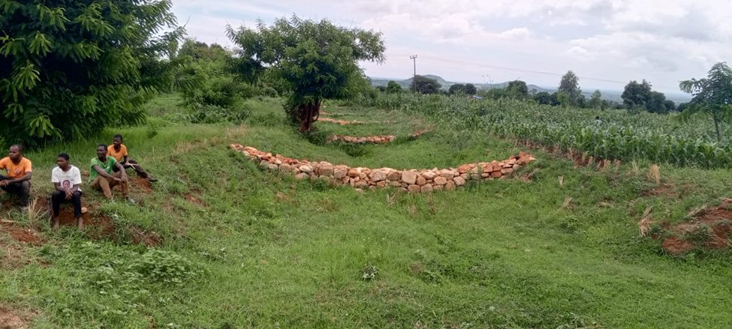

Fig above is a picture showing a well-constructed check dams in Lipunga Section, Mkanda EPA.

**CONSERVATION FARMING**

A total of 638ha were under conservation agriculture during the month, with the involvement of 1,862 farmers of which 1,059 are males and 803 are females, total to date is 14,206ha have been covered with the involvement of 36,291 farmers of which 21,411 are males and 14,880 are females, out of the annual target of 806 ha with the involvement of 2016 farmers of which 1008 are males and 1008 females.

A total of 108 ha of land have been managed under reduced tillage during the month with the involvement of 262 farmers of which 167 are males and 95 are females. To date 2,045 ha of land is under reduced tillage with 5,415 farmers involved of which 3,610 are male farmers and 1,805 female farmers out of annual target of 35 ha to be covered with 44 farmers from each gender.

A total of 4 ha land has been covered under pit planting during the month with 67 farmers being involved of which 39 are male farmers and 28 are female farmers. To date 31ha of land has been covered under pit planting with 808 farmers involved of which 503 are male farmers and 305 are female farmers.

A total of 33 ha of land have been covered with mulching materials in the district during the month with 99 farmers involved of which 42 are male farmers and 57 are female farmers. To date 4,498ha has been covered with mulching with 11,517 farmers being involved of which 7,516 are male farmers and 4,000 are female farmers out of annual target of 34 ha and 43 farmers from each gender.

A total of 19ha of land has been covered up with cover crop during the month with the involvement of 232 farmers of 151 are male farmers and 81 are female farmers. To date 1,980 ha have been covered up with cover crop with 5,455 farmers involved of which 3,448 are male farmers and 2,007 are female farmers out of the annual target of 10 ha of land to be covered with 13 farmers being involved from each gender.

A total of 348ha of land have been under rotation in this month with involvement of 1,505 farmers of which 867 are male farmers and 638 are female farmers. To date 12,397ha of land have been under rotation with the involvement of 30,408 farmers of which 18,846 are male farmers and are 11,562 female farmers out of the annual target of 500 ha and 625 farmers from each gender involved.

A total of 363ha of land is being managed under inter-cropping during the month which involves 2,013 farmers of which 1,131 are male farmers and 882 are female farmers. To date 4,262 ha of land have been managed under inter-cropping with 14,974 farmers being involved of which 8,757 are males and 6,217 are females out of annual target of 220 ha of land to be covered and 275 farmers from each gender to be involved.

**2.1.6.0 SOIL AND WATER CONSERVATION**

A total of 545 ha has been put under contour marker ridges construction this month which involved 1,400 participants of which 751 were males and 649 were females. To date 4,182ha of land have been put under contour marker ridges with 26,740 participants involved of which 15,403 are males and 11,337 are females out of an annual target of 100 ha with the involvement of 250 farmers of which 125 are males and 125 females.

A total of 570 ha was realigned with ridges following the marker ridges during the month which involved 2,199 participants of which 896 were males and 1,303 were females. To date 3,926 ha have been realigned with ridge following the marker ridges with 33,806 participants involved of which 18,177 are males and 15,629 are females out of an annual target of 100 ha with the involvement of 250 farmers of which 125 are males and 125 females.

A total length of 10,486 m has been covered with raised footpaths during the month with the involvement of 1,170 participants of which 601 were males and 569 females. To date 45,546 m have been covered with raised footpaths involving 18,836 participants of which 11,222 are males and 7,614 are females, out of an annual target of 14,960m raised footpath with the involvement of 15,040 of which 7,520 are males and 7,520 females.

A total of 1,091ha land has been covered with box ridges during the month with the involvement of 2,718 participants of which 1,511 are males and 1,207 are females. To date 4,778ha of land have been covered with box ridges with the involvement of 18,100 farmers of which 9,897 are males and 8,203 are females. out of an annual target of 100 ha with the involvement of 250 farmers of which 125 are males and 125 females.

A total of 5 storm drains of 11M long have been constructed during the month in the district with the involvement of 123 farmers of which 82 are male farmers and 41 are female farmers. To date 73 storm drains of 4,323M have been constructed with 1,107 participants involved where 573 are males and 534 are females out of an annual target of 2 storm drains of 200 M long with the involvement of 160 farmers of which 80 are males and 80 females.

A total of 55 gullies have been reclaimed of 10,330m long during the month with 1,146 participants involved of which 701 were males and 445 were female, to date 474 gullies of 50,067m long have been reclaimed with the involvement of 17,177 participants whereby 7,313 are males and 4,864 are females out of total annual target of 10 gullies of 3,000m involving 330 farmers of which 165 are males and 165 females.

No land has been covered with vertiva nurseries during the month in the district. To date 21 vetiver nurseries has been established in the district on 14 ha of land which involved 1003 participants of which 585 were males and 418 females against the total annual target of 7 nurseries for 7 ha with involvement of 120 male farmers and 120 female farmers.

118 vertiver hedge rows of 35,927 M have been constructed during the month with 1,541 participants involved of which 852 are males and 689 are females. To date 115 vetiver hedge rows of 42,114 M have been constructed with the involvement of 5,384 farmers of which 3,342 are males and 2,042 are females out of the annual target of 100 hedgerows, 45,000m with the involvement of 250 farmers of which 125 are males and 125 females.

A total of 10 streams covering 10,451m have been protected during the month with 573 participants involved of which 308 were males and 265 were females. To date 86 streams of 81,083m long have been protected with the involvement of 7,632 participants where 4,653 are males and 2,979 are females, out of the annual target of 30 stream banks covering 3,000m involving 150 farmers of which 75 are males and 75 females.

**STAFF AND FARMER TRAINING**

**STAFF TRAINING**

2 training session of staffs have been conducted during the month with 9 staff members involved of which 6 are males and 3 is a female. To date 17 training sessions have been conducted with the involvement of 224 frontline staff of which 142 are males and 81 are females, out of an annual target of 8 training sessions involving 97 frontline staff of which 77 are males and 20 females.

No staff field days have been conducted during the month. To date 3 staff members have been participating of which 1 was a male and 2 were females.

2 staff study tour have been conducted during the month involving 9 staff members of which 4 was a male and 5 were females. To date 3 staff study tours have been conducted with 12 staff members involved of which 5 are males and 7 are females.

**FARMER TRAINING**

A total of 40 Farmer training sessions have been conducted during the month on rain water harvesting practices, conservation farming, soil fertility improvement and soil and water conservation with the involvement of 1,552 farmers of which 920 were males and 632 were females, to date 454 training sessions have been conducted with the involvement of 29,835 farmers have been trained on various technologies of which 18,822 are males and 11,013 are females, out of an annual target of 165 sessions with the involvement of 4,950 farmers of which 2,475 are males and 2,475 females.

**DEMONSTRATIONS**

A total of 25 demonstration sessions were conducted on various land conservation technologies during the month with the involvement of 828 farmers of which 428 are males and 400 are females, to date 440 demonstration sessions have been carried out with the involvement of 19,582 farmers of which 10,889 are males and 8,693 are females, out of an annual target of 165 demonstration sessions with the involvement of 4,950 farmers of which 2,475 are males and 2,475 females.

**FIELD DAY**

No any field day has been conducted during the month. To date 26 field days have been conducted which involved 3,705 farmers of which 2,107 are males and 1,598 are females, out of the annual target of 4 with the involvement of 220 participants of which 110 are males and 110 females.

**STUDY TOURS**

No any study tour has been conducted in the district during the month. To date 3 study tours has been conducted with 57 participants taking place of which 31 are males and 26 are females out of annual target of 1 tour to be conducted with 34 participants involved and 17 people from each gender.

**2.2.6 CAMPAIGN/AWARENESS MEETING**

A total of 8 campaign meetings have been conducted during the month on various land resource conservation technologies with the involvement of 1,571 farmers of which 628 are males and 943 are females, to date 245 campaign meetings has been conducted on various technologies with the involvement of 62,787 farmers of which 31,219 are males and 31,568 are females, out of an annual target of 56 campaigns with the expected attendance of 2,800 farmers of which 1,400 are males and 1,400 females.

**ENVIRONMENTAL CONSERVATION CLUB**

No any club has been formed during the month in the district. To date 2 club has been formed with 240 participants where 124 are males and 116 are females out of the annual of 7 clubs to be formed with 210 participants, 105 from each gender.

2.5.5 SENSITIZATION MEETINGS ON ENVIRONMENTAL CONSERVATION

A total of 12 sensitization meetings were conducted during the month with the involvement of 2,446 farmers of which 1,185 are males and 1,261 are females, to date 157 sensitization meetings have been conducted with the involvement of 35,896 farmers of which 17,420 are males and 18,476 are females out of an annual target of 42 meetings with the involvement of 2,100 farmers of which 1,050 are males and 1,050 females.

**2.5.6 AWARENESS ON ENVIRONMENTAL ISSUES**

No awareness meeting has been conducted during the month out of the total annual target of 7 meetings with involvement of 210 farmers of which 105 are males and 105 females.

**Plans for the Month of March**

1. Sensitization campaigns on manure and use
2. Conducting field days
3. Payment of participants for CSEPWP

**NGOS Supporting Land Resources Activities**

|  |  |  |  |  |  |
| --- | --- | --- | --- | --- | --- |
| **NAME OF NGO** | **SERVICES PROVIDED/VALUE CHAINS BEING PROMOTED** | **LOCATION** | **FOCAL PERSON** | **CONTACTS** | **MOU WITH THE DC** |
| CICOD | Integrated catchment management | Zulu, kalulu, Mlonyeni | Amos Tizora | 0999855081 | Not yet |
| [amostizora@yahoo.co.uk](mailto:amostizora@yahoo.co.uk) |
| TOTAL LAND CARE | CSA | Kalulu, Mkanda,Mikundi and Chioshya | Richard Mseka | [Richard Mseka, rmseka@tlc.mw.org](mailto:rmseka@tlc.mw.org) | Available |
| AG CARE | CSA | Chioshya |  |  |  |
| FAO | CSA | Mkanda,Mikundi and kalulu | Stewart Chikomola | [Stewart.chikomola@fao.org,0999101714](mailto:Stewart.chikomola@fao.org,0999101714) | Available |
| PUMP AID | Integrated Catchment Management | Kalulu,Mikundi,Chioshya and Mlonyeni |  |  |  |

### **2.1.4 Crops Development highlights of achievements**

**2.1.4.1 Crop status February 2025**

Most of the irrigated crops were harvested while in rain fed the crop ranged from vegetative growth to maturity.

**2.1.4.2 Marketing of Major Crops and Livestock Products**

* 1. **Table 3** Market price of commodities as of 25 February 2025

Commodity prices for most of the crop produce, livestock and livestock products are high compared to same time last season. The price of maize grain ranged from MK1300 to MK1700 per Kg while same time last year it was between MK400 to MK600 per kilogram**.** (**Table 3).**

|  |  |  |
| --- | --- | --- |
| **Commodity** | **Price (MK) per KG** | |
| **2024/2025** | **2023/2024** |
| Maize Grain | 1300-1700 | 400/600 |
| Polished Rice | 3000/3500 | 1800/2500 |
| Potato | 1000/1500 | 800/1000 |
| Cassava Root | 1000/1200 | 1200/1500 |
| SweetPotato | 500/1000 | 300-500 |
| Mixed Beans | 6000/8000 | 2500/3000 |
| G/nuts Shelled | 6000/8000 | 1000/2600 |

1. Table 4: Livestock-based commodity prices as of February 11, 2025

|  |  |  |
| --- | --- | --- |
| **Commodity** | **Price (MK )** | |
| **2024/2025** | **2023/2024** |
| Milk (Litre) | 1000/1800 | 1000/1200 |
| Chicken Egg | 300/350 | 200/250 |
| Live Chicken | 8000/12000 | 2500-6000 |
| Live Goat | 45000/60000 | 25000-60000 |
| Live Cattle | 200,000 - 800,000 | 200,000-350,000 |
| Live Pig | 40,000 - 150, 000 | 30,000-120,000 |
| Beef per Kg | 6000 – 8000 | 3,500-5,000 |
| Pork per Kg | 3,500 - 6, 000 | 2,800-4,000 |



**2.1.4.6 Crops Plans for March, 2025**

|  |  |  |  |
| --- | --- | --- | --- |
| **Output / Activity** | **Monitoring**  **Indicator** | **Annual**  **Target** | **Monthly Target** |
| **Access and use of recommended farm inputs increased** |  |  |  |
| Promote accessibility and use of recommended farm inputs.  (i) Seed  (ii) Fertilizer  (iii) Pesticides | Quantity in MT/*L* | 50  4359.6  1000 | 29  2619.95  100 |
| Monitoring of AIP sales and uptake | No. of visits | 8 | 3 |
|  |  |  |  |
| **Crop diversification promoted** |  |  |  |
| Conduct supervisory visits | No. of visits | 20 | 3 |
|  |  |  |  |
| **Crop production service delivery improved** |  |  |  |
| Monitor crop production and development in relation to weather | No. of visits | 20 | 5 |
| Conduct training of AEDOS on potato production and marketing |  |  |  |
| **Fruit production improved** |  |  |  |
| Conduct supervisory visits on crop protection activities | No. of visits | 12 | 1 |
| **Access to farm mechanization technologies increased** |  |  |  |
| Facilitate khola maintenance | No. of Kholas | 2 | 0 |
|  |  |  |  |

* Compile crops fortnightly report.
  + 1. **Livestock Production**

**Objectives/Outputs**

* Production of Livestock improved.
* Availability of domestic livestock products improved.
* Animal diseases incidences reduced.
* Veterinary Public health services improved.
* Delivery of livestock programs improved.

**Strategies**

* Broadening livestock ownership
* Improvement of public health against zoonotic and food borne diseases.
* Reduction of disease incidences through promotion of treatments and vaccinations.
* Promotion of plunge dipping, spraying and pour on to control external parasites
* Deworming as one way of controlling endo and parasites.

**Staffing Position**

**Table 1: Staffing levels for Mchinji February, 2025**

|  |  |  |  |
| --- | --- | --- | --- |
| **POST** | **ESTABLISHED POSTS** | **NO. OF ESTABLISHMENT POST** | **POSTS FILLED** |
| AHLDO | I(CTO/PO) | 1 | 0 |
| INTERNEE |  | 0 | 1 |
| SAVO | J(SAVO) | 0 | 1 |
| AVO | K(AVO) | 9 | 5 |
| AHSA | P(AHSA) | 9 | 17 |

* 1. **Livestock Condition**

Most livestock classes were in good condition due to availability of feed in form of crop residues, natural pasture and madeya preserved by farmers and water for drinking.

**1.3 Dog Bites**

The district recorded 73 dog bite cases and 1 was not recommended for anti-rabies vaccine.

**1.4 Veterinary Interventions**

Frontline staff conducted treatments, vaccinations, de-worming, castrations and parasite control in animals during the month.

**1.5 Rabies Vaccination**

The district received 1000 vials of Rabsin from DAHLD and total of 10000 dogs are expected to be vaccinated in this year across the district. A total of **188** dogs were vaccinated in February, 2025 and a total of **8459** of dogs have been vaccinated to date.

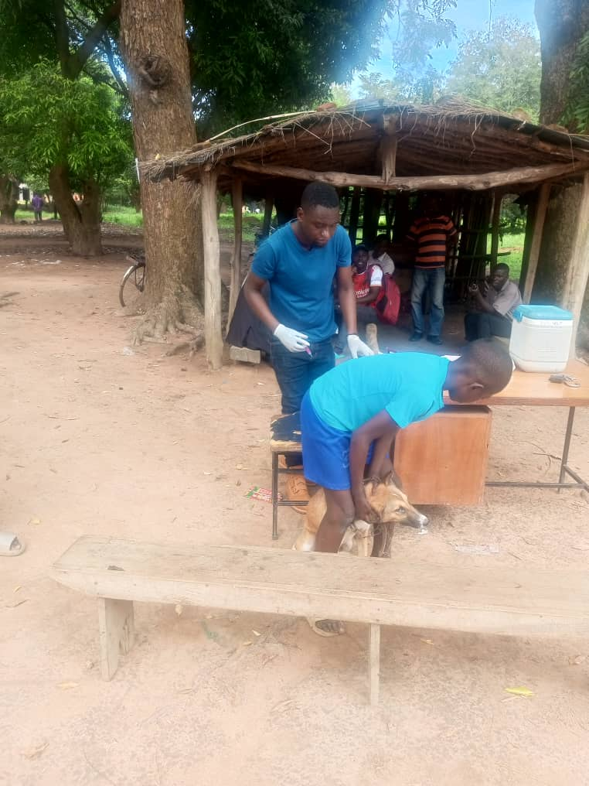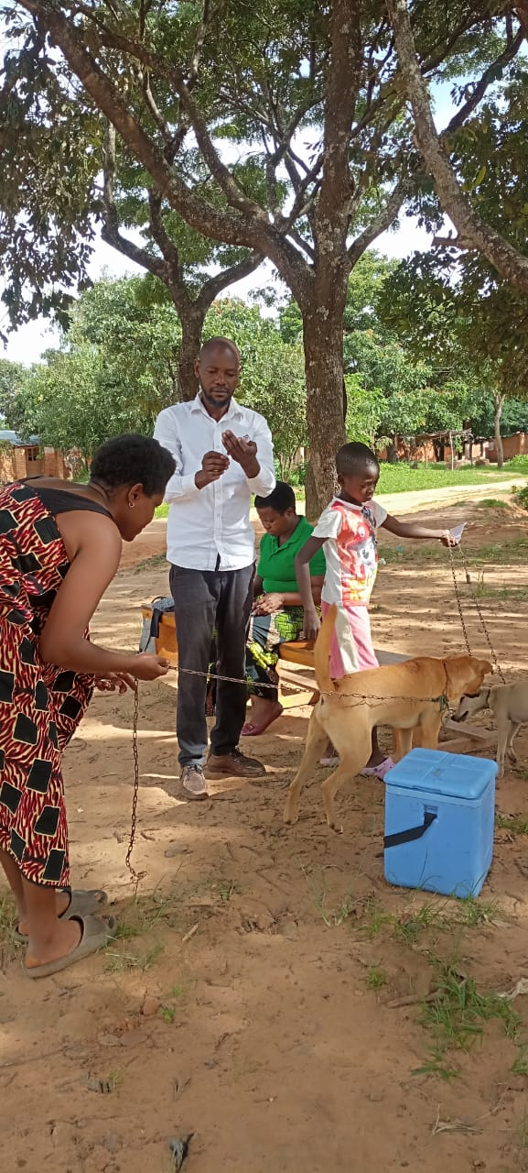

*Figure 1:* Rabies vaccination in Chioshya and Zulu EPAs, Nkhomba Vilg and Chioshya TC, Feb 2025

1.**6 Lumpy Skin Disease Sensitization Campaign**

Mchinji district through AVO received a report that some animals were manifesting signs of LSD in Mkanda EPA. The cases were reported on 20th November 2024 and AVO went to verify on 24th November 2024.DAHLDO reported and filled the emergency reporting form immediately and started sensitisation.

Currently the Dustrict is doing vaccinations across the seven EPAs, and in this month of February three EPAs, namely Mlonyeni, kalulu, and Mkanda a total of 2274 cattle have been vaccinated. The district is facilitating resource mobilisation and started vaccinations on 31 December, 2024 and to date **4485** cattle have been vaccinated.

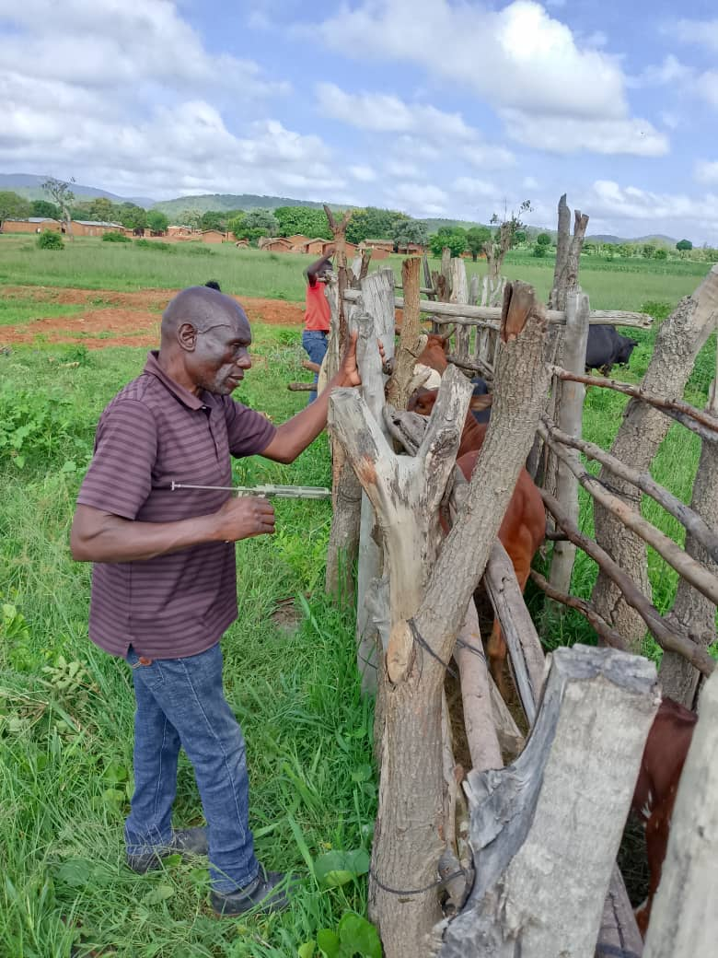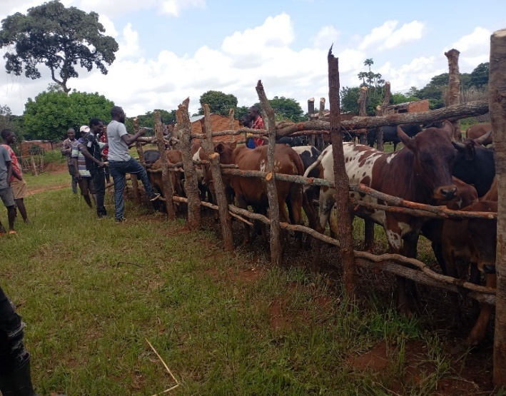

*Figure 2:* LSD Vaccination in Mlonyeni and Mkanda EPAs, Feb. 2025

**ACTIONS TAKEN BY DISTRICT**

* Doing sensitisations across the district
* Convincing farmers to mobilise resources
* Facilitating procurement of vaccines and doing vaccinations
* Intensifying active surveillance

Table 2: LSD Cattle vaccination in Mchinji, 2024-25

|  |  |
| --- | --- |
| **Centre** | **No. Vaccinated** |
| **MLONYENI EPA** |  |
| Ndawambe | 586 |
| Molosiyo | 237 |
| Chisenga | 243 |
| Tembwe Dip Tank | 602 |
| Kholoni | 342 |
| Tsumba1 | 212 |
| Kachebere | 85 |
| **TOTAL** | **2307** |
| **MKANDA EPA** |  |
| Gada Farm | 182 |
| Mkanda Dip Tank | 1268 |
| **KALULU EPA** |  |
| Kapiri | 62 |
| TCG Farm | 231 |
| Goshen Farm | 241 |
| Sagawa Farm | 89 |
| Chimunthu Farm | 35 |
| Mphatso Farm | 55 |
| Hasrood Farm | 15 |
| **TOTAL** | **728** |
| **TOTAL CATTLE VACCINATED** | 4485 |

**Challenges**

* Mobility and scarcity of fuel
* Some farmers not willing to mobilise resources for vaccination
* Shortage of automatic syringes

**1.7 NGOs Pass on Programs**

Girls Activist Youth Organisation **(GAYO)** under World Vision Malawi which is implementing a project in Kalulu EPA in the Traditional Authority Kapondo has distributed 30 piglets to 10 youths **(4M, 6F)** The aim is to build capacity among the youths starting from a tender age through livestock farming, poultry and piggery in particular. Ten youths plus their parents underwent a training in piggery for five days in December 2024 and have now received three pigs each which are meant for Pass on Program. Parents were also in attendance just in order to encourage and support the youths.

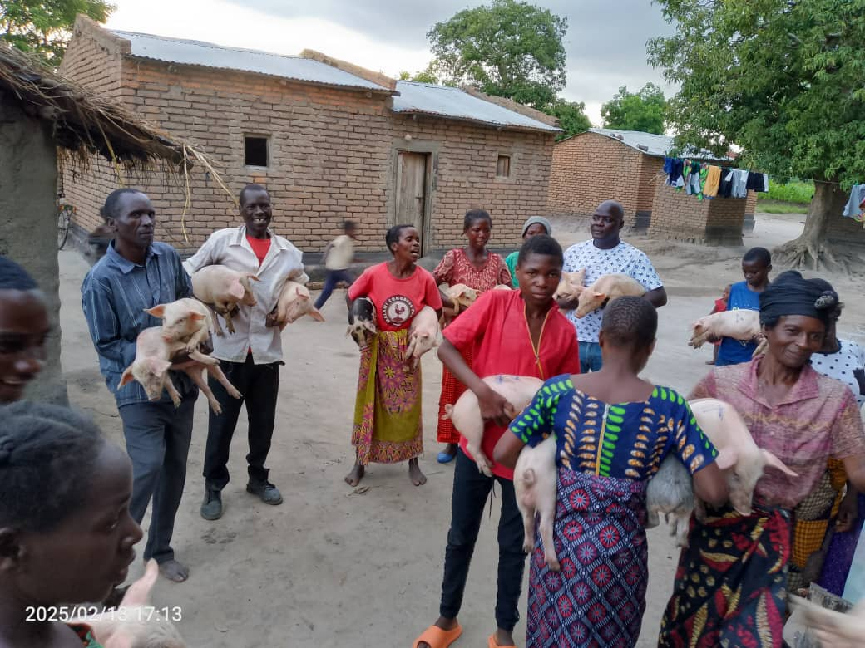

*Figure 3:* Beneficiaries receiving Pig weaners in Kalulu EPA, Feb 2025

**Compiled By:**

Abraham Mhlanga

Chief Agriculture Officer

P.O. Box 7, Mchinji

**Contacts**

Mobile: +265 991 452 891

Email: [abuhmhlanga@gmail.com](mailto:abuhmhlanga@gmail.com)

**Received By:**

Mr. Hastings Yotamu

**Director of Agriculture Services**

Mobile: +265 999 212 081

Email: [yothess@gmail.com](mailto:yothess@gmail.com)